Step Calibration Instructions For Broadband (feedback) Sensors Using Clie Programs for Q330 or RT130 stations in the Field

Part I. Calibrating Sensors at the Q330 Stations:
Use Clie program Q330Beta (must be version 1.44t or higher)

Cmd -> Calibration

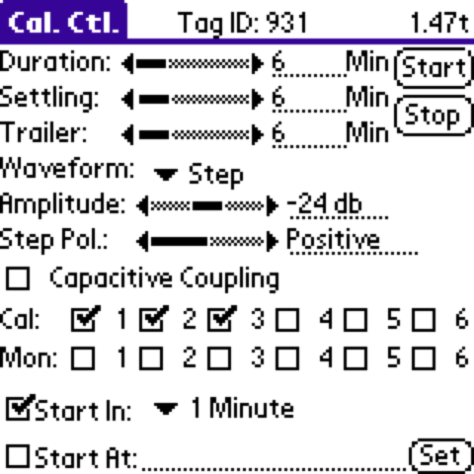

DURATION bar: 6 min
SETTLING bar: 6 min
TRAILER bar: 6 min

Waveform: STEP
Amplitude bar: -24 dB for Guralp, -18 dB for STS-2
Step polarity: Positive

Cal: checkbox 1 checkbox 2 checkbox 3 (Check all 3 Channels for step cal signal)
Check Start In: 1 Minute
Press Start button (in upper right of Cal. Ctl. Clie Screen, shown above)

Wait quietly about 20 minutes
You want the calibration to finish before you write the data to the Baler (follow Service Sheet instructions for powering Baler and checking the Data Port Transfer).

Step Calibration Instructions For Broadband (feedback) Sensors Using Clie Programs for Q330 or RT130 stations in the Field

Part II. Calibrating Sensors at the RT130 Stations:
Use Clie program PFC_130 (Any version we’ve tried works; we haven’t gone beyond v 1.3.0.03 as of Aug ‘09)

First check the RT130 calibration parameters already programmed at the RT130 station:
Work with Configuration -> From DAS ->Edit -> Sensor Test…

Channel group: 1-3, Enable: ON
Signal type: STEP
Amplitude: 0.7 V
Duration: 1000 sec
Pulse width: 300 sec
Pulse interval: 600 sec

If the parameters match, then: -> Cancel and go to RUNNING THE CALIBRATION below.

If the parameters do not match those above you will want to change them to match the example, then: -> Apply -> Apply and -> Send to DAS
NOTE: the ‘Send to DAS’ Command will automatically Stop Acq!!
You must go to
Control -> Status -> Start Acq

After Acquisition has resumed you may run the calibration:

RUNNING THE CALIBRATION
Control -> Aux. Cntrl -> Test 1-3...…

If the site is quiet, you should hear a relay click.
Wait quietly about 20 minutes before you Stop Acq.

